8-bit ALU design with 16 choices IC

A Project Report

In the partial fulfillment of the award of the degree of

B. Tech
at

Ardent Computech Pvt. Ltd


Submitted by
Sayan Sengupta
Sayan Samadder
Swapnanil Basuthakur
Subhajit Kumar Das
Rana Biswas
Rakhesh Dey
Sudhamay Sardar

Rajeet Gourav

JIS College of Engineering

Certificate from the Mentor

This is to certify that Sayan Sengupta, Sayan Samadder, Subhajit Kumar Das, Rana Biswas, Rakhesh Dey, Swapnanil Basu Thakur, Sudhamay Sardar and Rajeet Gourav has completed the project titled 8-bit ALU design with 16 choices IC under my supervision during the period from 16/02/2026 to 27/02/2026 which is in partial fulfillment of requirements for the award of the B.Tech and submitted to Department Electronics and Communication Engineering of JIS College of Engineering.



Signature of the Mentor

Date: 26/02/2026

Acknowledgment

I take this opportunity to express my deep gratitude and sincerest thanks to my project mentor, Debtanu Mondal for giving the most valuable suggestions, helpful guidance, and encouragement in the execution of this project work.

I would like to give a special mention to my colleagues. Last but not least I am grateful to all the faculty members of the Ardent Computech Pvt. Ltd. for their support.

8-BIT ALU DESIGN WITH 16 CHOICES IC

Abstract

This project presents the design and simulation of an 8-bit Arithmetic Logic Unit (ALU) using VHDL. The ALU is a fundamental component of digital systems and processors, responsible for performing arithmetic and logical operations. The designed ALU accepts two 8-bit input operands and a 4-bit selection signal to execute sixteen different operations, including addition, subtraction, multiplication, division, AND, OR, XOR, NOT, increment, decrement, and shift operations. The design utilizes IEEE standard libraries, specifically STD_LOGIC_1164 and NUMERIC_STD, to ensure proper arithmetic processing through unsigned data type conversion. The complete design was simulated and verified using ModelSim. The results confirm correct functionality for all selected operations, demonstrating effective implementation of combinational logic using VHDL.
Table of Contents
Introduction 6
OBJECTIVES 6
Background 7
Understanding FPGA: Field-Programmable Gate Array 7
Introduction to Xilinx 9
Sample VHDL CODE 10
Tools / Environment Used 21
Design Methodology 21

VHDL Code 21
Simulation and Verification 22
Implementation on Spartan 7 FPGA 23
Spartan 7 FPGA development board 23
FPGA Configuration 24
Testing and Results 25
Conclusion 26
References 27

Introduction

This project presents the design and simulation of an 8-bit Arithmetic Logic Unit (ALU) using VHDL in ModelSim. The ALU is a fundamental component of digital systems and processors, responsible for performing arithmetic and logical operations on binary data.

The designed ALU accepts two 8-bit input operands and a 4-bit selection signal to perform sixteen different operations. These operations include arithmetic functions such as addition, subtraction, multiplication, and division, as well as logical operations like AND, OR, XOR, NOT, and bit shifting. The output of the ALU is an 8-bit result generated based on the selected operation.

The project was implemented using IEEE standard libraries, particularly STD_LOGIC_1164 and NUMERIC_STD, ensuring proper handling of arithmetic operations through unsigned data type conversion. The design was verified through simulation in ModelSim to ensure correct functionality.

This project demonstrates the practical implementation of digital arithmetic and logical operations using Hardware Description Language (HDL), reinforcing concepts of combinational logic design and digital system architecture.

Objectives

The purpose of this project is:
- To design and implement an 8-bit Arithmetic Logic Unit (ALU) using VHDL.
- To perform sixteen different arithmetic and logical operations using a 4-bit control signal.
- To understand the use of IEEE standard libraries (STD_LOGIC_1164 and NUMERIC_STD) for digital design.
- To practice type conversion between STD_LOGIC_VECTOR and unsigned for arithmetic operations.
- To implement multiplication and division operations with proper handling of overflow and divide-by-zero conditions.
- To simulate and verify the functionality of the ALU using ModelSim.
- To develop a clear understanding of combinational logic design in hardware description languages.

Background

Understanding FPGA: Field-Programmable Gate Array

Field-Programmable Gate Arrays (FPGAs) are integrated circuits designed to be configured by the customer or designer after manufacturing—hence "field-programmable". They consist of an array of programmable logic blocks and a hierarchy of reconfigurable interconnects that allow these blocks to be wired together. This structure allows FPGAs to be programmed to perform complex digital computations and tasks.

Key Characteristics of FPGAs
- Reconfigurability:- FPGAs can be reprogrammed to perform different functions or to optimize the performance of existing functions, making them highly versatile for various applications.
- Parallel Processing:- Unlike traditional processors that execute instructions sequentially, FPGAs can perform multiple operations in parallel, significantly increasing computational efficiency for specific tasks.
- Low Latency:- FPGAs can process data with very low latency because they can be tailored to the specific needs of an application, reducing the need for additional processing steps.
- Customizability:- FPGAs allow for the implementation of custom hardware designs, which can be optimized for performance, power consumption, or both.
FPGA Architecture
- Configurable Logic Blocks (CLBs):- CLBs are the primary logic units in an FPGA. They contain look-up tables (LUTs), flip-flops, and multiplexers that can be configured to implement various logic functions.
- Interconnects:- FPGAs use a complex matrix of interconnects to route signals between CLBs. These interconnects can be dynamically programmed to connect the desired logic blocks.
- I/O Blocks:- Input/ Output blocks interface the FPGA with external devices. These blocks support various I/O standards and protocols, enabling the FPGA to communicate with other components in a system.
- Memory Blocks:- FPGAs include dedicated memory blocks for temporary data storage, which can be used for tasks like buffering and caching.
- Clock Management:- Clock management resources, such as phase-locked loops (PLLs) and clock dividers, are included to manage the timing of operations within the FPGA.
FPGA Development Process
- Design Entry:- The design process starts with defining the logic and functionality, typically using Hardware Description Languages (HDLs) like VHDL or Verilog.

- Simulation:- Before implementing the design on hardware, it is simulated to verify its correctness. Simulation tools allow designers to test and debug their logic.

- Synthesis:- The HDL code is synthesized into a netlist, which describes the hardware components and their interconnections.
- Implementation:- The netlist is mapped to the FPGA’s resources (CLBs, interconnects, etc.). This step involves place-and-route algorithms to optimize the design’s performance.
- Programming:- The final step is to generate a bitstream file, which is used to program the FPGA. This file configures the FPGA to implement the desired logic.
- Verification and Testing:- After programming the FPGA, the design is verified and tested in hardware to ensure it meets all functional and performance requirements.
Applications of FPGAs
- Telecommunications:- FPGAs are used in network routers, switches, and base stations to perform high-speed data processing and protocol management.
- Consumer Electronics:- In devices like digital cameras, smartphones, and gaming consoles, FPGAs are used for image processing, signal processing, and interfacing with other components.
- Automotive:- FPGAs are employed in advanced driver-assistance systems (ADAS), infotainment systems, and electronic control units (ECUs).
- Industrial Automation:- In industrial control systems, FPGAs provide the flexibility and performance required for real-time processing and control.
- Aerospace and Defense: - FPGAs are used in radar systems, communication devices, and avionics due to their reliability and reconfigurability.
- Medical Devices:- FPGAs enable high-performance processing in medical imaging systems, diagnostic equipment, and portable medical devices.
Advantages of FPGAs
- Flexibility:- Ability to reprogram for different applications and updates.
- Performance High-speed data processing with parallel execution.
- Customization: Tailored hardware solutions for specific needs.
- Scalability: Suitable for a wide range of applications from small devices to large systems.
Disadvantages of FPGAs
- Cost: Higher initial cost compared to ASICs for large-volume production.
- Power Consumption: Can consume more power than fixed-function devices.
- Complexity: Requires specialized knowledge for design and programming.
Introduction to VHDL Programming
VHDL (VHSIC (Very High Speed Integrated Circuits) hardware description language) is commonly used as a design-entry language for field-programmable gate arrays and application-specific integrated circuits in electronic design automation of digital circuits. VHDL was originally developed at the behest of the US Department of Defense in order to document the behavior of the ASICs that supplier companies were including in equipment. That is to say, VHDL was developed as an alternative to huge, complex manuals which were subject to implementation-specific details.
The idea of being able to simulate this documentation was so obviously attractive that logic simulators were developed that could read the VHDL files. The next step was the development of logic synthesis tools that read the VHDL, and output a definition of the physical implementation of the circuit. Modern synthesis tools can extract RAM, counter, and arithmetic blocks out of the code, and implement them according to what the user specifies. Thus, the same VHDL code could be synthesized differently for lowest area, lowest power consumption, highest clock speed, or other requirements.
VHDL borrows heavily from the Ada programming language in both concepts (for example, the slice notation for indexing part of a one-dimensional array) and syntax. VHDL is not a case sensitive language. One can design hardware in a VHDL IDE (such as Xilinx or Quartus) to produce the RTL schematic of the desired circuit. After that, the generated schematic can be verified using simulation software (such as ModelSim) which shows the waveforms of inputs and outputs of the circuit after generating the appropriate test bench. To generate an appropriate test bench for a particular circuit or VHDL code, the inputs have to be defined correctly. For example, for clock input, a loop process or an iterative statement is required.
The key advantage of VHDL when used for systems design is that it allows the behavior of the required system to be described (modeled) and verified (simulated) before synthesis tools translate the design into real hardware (gates and wires). Another benefit is that VHDL allows the description of a concurrent system (many parts, each with its own sub-behavior, working together at the same time). VHDL is a Dataflow language, unlike procedural computing languages such as BASIC, C, and assembly code, which all run sequentially, one instruction at a time.

Introduction to Xilinx

Xilinx ( an Electronics Company ) is the world’s largest supplier of programmable logic devices and the inventor of the field programmable gate array (FPGA). Today Xilinx is the worldwide leader of complete programmable logic solutions.
Xilinx has two main FPGA families – the high-performance video Virtex series and the high-volume Spartan series. Each model series has been released in multiple generations since its launch. The latest Virtex-6 and Spartan-6 FPGA families are said to consume 50 % less power , cost 20 % less , and have up to twice the logic capacity of previous generations of FPGAs. The Spartan series targets applications with low power footprint, extremes cost sensitivity and high volume e.g. displays, set top boxes wireless routers and other applications.
The ISE Design Suite is the central electronic design automation (EDA) product family sold by Xilinx .The ISE Design Suite features include design entry and synthesis supporting Verilog or VHDL ,place and route (PAR), completed verification and Chipscope pro tools , and creation of the bit files that are used to configure the chip .
Xilinx designs, develops and markets programmable logic products including integrated circuits (ICs), software design tools and services . Xilinx sells both FPGAs and CPLDs (Complex Programmable Logic Devices) for electronic equipment manufacturers.
In this project we used the Xilinx Vivado 2023.2 version to complete our project.

1-BIT NOT GATE

TRUTH TABLE
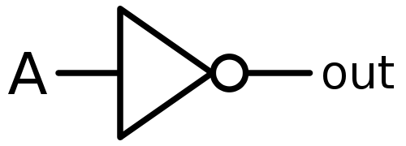
Input | Output
A | Y
0 | 1
1 | 0

VHDL CODE

library ieee;
use ieee.std_logic_1164.all;
entity not_gate is
port (a:in std_logic;
c:out std_logic);
end not_gate;
architecture Behavioral of not_gate is
begin
C<= not A;
end Behavioral

TEST BENCH WAVEFORM

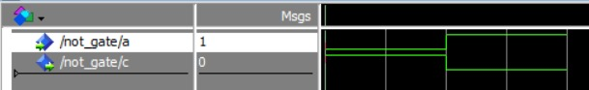

1-BIT OR GATE
TRUTH TABLE
Inputs |  | Output
A | B | Y
0 | 0 | 0
0 | 1 | 1
1 | 0 | 1
1 | 1 | 1

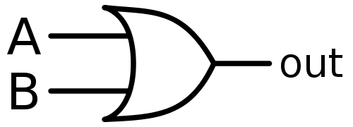

VHDL CODE
library ieee;
use ieee.std_logic_1164.all;
entity or_gate is
port (a:in std_logic;
b:in std_logic;
c:out std_logic);
end or_gate;
architecture Behavioral of or_gate is
begin
C<= A or B;
end Behavioral;

TEST BENCH WAVEFORM

4-BIT OR GATE
VHDL CODE
library ieee;
use ieee.std_logic_1164.all;
entity or_4 is
port (a:in std_logic_vector(0 to 3);
b:in std_logic_vector(0 to 3);
c:out std_logic_vector(0 to 3));
end or_4;
architecture Behavioral of or_4 is
begin
c<= A or B;
end Behavioral;

TEST BENCH WAVEFORM

1-BIT AND GATE

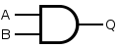
TRUTH TABLE
Inputs |  | Output
A | B | Y
0 | 0 | 0
0 | 1 | 0
1 | 0 | 0
1 | 1 | 1

VHDL CODE

library ieee;
use ieee.std_logic_1164.all;
entity and_gate is
port (a:in std_logic;
b:in std_logic;
c:out std_logic);
end and_gate;
architecture Behavioral of and_gate is
begin
C<= A and B;
end Behavioral;

TEST BENCH WAVEFORM

4-BIT AND GATE

VHDL CODE
library ieee;
use ieee.std_logic_1164.all;
entity and_4 is
port (a:in std_logic_vector(0 to 3);
b:in std_logic_vector(0 to 3);
c:out std_logic_vector(0 to 3));
end and_4;
architecture Behavioral of and_4 is
begin
c<= A and B;
end Behavioral;

TEST BENCH WAVEFORM

Tools / Environment Used
HARDWARES:

- PINE S7 FPGA DEVELOPMENT BOARD : SPARTAN 7
- Hard disk : 320 GB or higher
- Processor : Intel i3
- Ram : 4 GB and above
- USB CABLE : B TYPE

SOFTWARES:
- OPERATING SYSTEM : Windows 10/11
- DEVELOPMENT SOFTWARE : Xilinx VIVADO 2023.2 or above
Design Methodology – 8-Bit ALU with 16 Operations (VHDL)

Step 1 → Project Creation
A new project named 8-Bit ALU Design was created in ModelSim/Vivado.
The objective of this project was to design and simulate an 8-bit Arithmetic Logic Unit (ALU) capable of performing 16 different operations using a 4-bit select line.

Step 2 → File Creation
Three main files were created:
- Design File (ALU_8_bit.vhd)
- Test Bench File (ALU_TB.vhd)
- Constraint File (.xdc) (for FPGA implementation)

Design File
The Design File contains the complete logic implementation of the 8-bit ALU.
- Four ports were defined:
  - A → 8-bit input
  - B → 8-bit input
  - SEL → 4-bit select line
  - Y → 8-bit output
- STD_LOGIC_VECTOR datatype was used for input and output ports.
- For arithmetic operations, inputs were converted to unsigned using IEEE.NUMERIC_STD.ALL.
- Internal signals A_u and B_u were declared as unsigned(7 downto 0).
- A combinational process block was used with a case statement to implement 16 operations.

Test Bench File
The Test Bench file was created to verify the functionality of the ALU design.
- The ALU entity was instantiated.
- Signals for A, B, SEL, and Y were declared.
- Different input combinations were applied sequentially.
- All 16 select values (0000 to 1111) were tested.
- Simulation was carried out using ModelSim.
- Waveform analysis was used to verify correctness of each operation.
This step ensured that:
- Arithmetic operations were correct.
- Logical operations were correct.
- Multiplication produced correct lower 8-bit output.
- Division handled divide-by-zero properly.
The test bench validated the complete functionality before FPGA implementation.

Constraint File
The Constraint File (.xdc) is used for FPGA hardware implementation.
- Logical ports defined in the VHDL design were mapped to physical FPGA pins.
- Input switches were mapped to:
  - A[7:0]
  - B[7:0]
  - SEL[3:0]
- Output LEDs were mapped to Y[7:0].
The constraint file ensures that:
FPGA switches correctly provide input signals.
- LEDs correctly display ALU output.
- Pin mapping matches the FPGA board user manual.

VHDL Code

library IEEE;

use IEEE.STD_LOGIC_1164.ALL;

use IEEE.NUMERIC_STD.ALL;

entity ALU_8_bit is

Port (

A : in STD_LOGIC_VECTOR(7 downto 0);

B : in STD_LOGIC_VECTOR(7 downto 0);

SEL : in STD_LOGIC_VECTOR(3 downto 0);

Y : out STD_LOGIC_VECTOR(7 downto 0)

);

end ALU_8_bit;

architecture Behavioral of ALU_8_bit is

signal A_u, B_u : unsigned(7 downto 0);

signal RESULT : unsigned(7 downto 0);

begin

A_u <= unsigned(A);

B_u <= unsigned(B);

process(A_u, B_u, SEL)

variable MUL_FULL : unsigned(15 downto 0);

begin

case SEL is

-- 0000 ADD

when "0000" =>

RESULT <= A_u + B_u;

-- 0001 SUB

when "0001" =>

RESULT <= A_u - B_u;

-- 0010 MUL (lower 8 bits only)

when "0010" =>

MUL_FULL := A_u * B_u;

RESULT <= MUL_FULL(7 downto 0);

-- 0011 DIV

when "0011" =>

if B_u /= 0 then

RESULT <= A_u / B_u;

else

RESULT <= (others => '0');

end if;

-- 0100 AND

when "0100" =>

RESULT <= A_u and B_u;

-- 0101 OR

when "0101" =>

RESULT <= A_u or B_u;

-- 0110 XOR

when "0110" =>

RESULT <= A_u xor B_u;

-- 0111 NOT A

when "0111" =>

RESULT <= not A_u;

-- 1000 NAND

when "1000" =>

RESULT <= not (A_u and B_u);

-- 1001 NOR

when "1001" =>

RESULT <= not (A_u or B_u);

-- 1010 XNOR

when "1010" =>

RESULT <= not (A_u xor B_u);

-- 1011 INC (A + 1)

when "1011" =>

RESULT <= A_u + 1;

-- 1100 DEC (A - 1)

when "1100" =>

RESULT <= A_u - 1;

-- 1101 SHL (Shift Left Logical)

when "1101" =>

RESULT <= shift_left(A_u, 1);

-- 1110 SHR (Shift Right Logical)

when "1110" =>

RESULT <= shift_right(A_u, 1);

-- 1111 PASS (Output A)

when "1111" =>

RESULT <= A_u;

-- Default

when others =>

RESULT <= (others => '0');

end case;

end process;

Y <= std_logic_vector(RESULT);

end Behavioral;

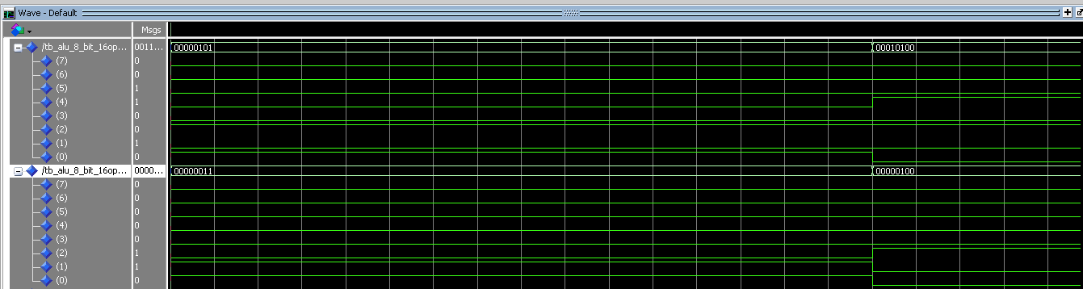

FIGURE: Design Waveform

Simulation and Verification

The VHDL code is first simulated using simulation tool such of Vivado to verify the correctness of the logic. The simulation involves applying different inputs and observing the corresponding outputs on the Spartan 7 FPGA Development Board.

VHDL TESTBENCH FILE CODE

library IEEE;
use IEEE.STD_LOGIC_1164.ALL;
use IEEE.NUMERIC_STD.ALL;

entity tb_ALU_full is
end tb_ALU_full;

architecture Behavioral of tb_ALU_full is

component ALU_8_bit
Port (
A : in STD_LOGIC_VECTOR(7 downto 0);
B : in STD_LOGIC_VECTOR(7 downto 0);
SEL : in STD_LOGIC_VECTOR(3 downto 0);
Y : out STD_LOGIC_VECTOR(7 downto 0)
);
end component;

signal A : STD_LOGIC_VECTOR(7 downto 0);
signal B : STD_LOGIC_VECTOR(7 downto 0);
signal SEL : STD_LOGIC_VECTOR(3 downto 0);
signal Y : STD_LOGIC_VECTOR(7 downto 0);

begin

UUT: ALU_8_bit
port map (
A => A,
B => B,
SEL => SEL,
Y => Y
);

stimulus : process
variable A_int, B_int : unsigned(7 downto 0);
variable expected : unsigned(7 downto 0);
variable mul_full : unsigned(15 downto 0);
begin

-- Test several input combinations
for i in 0 to 5 loop

A_int := to_unsigned(i*15 + 5, 8);
B_int := to_unsigned(i + 3, 8);

A <= std_logic_vector(A_int);
B <= std_logic_vector(B_int);

for op in 0 to 15 loop

SEL <= std_logic_vector(to_unsigned(op,4));
wait for 10 ns;

case op is

when 0 => -- ADD
expected := A_int + B_int;

when 1 => -- SUB
expected := A_int - B_int;

when 2 => -- MUL
mul_full := A_int * B_int;
expected := mul_full(7 downto 0);

when 3 => -- DIV
if B_int /= 0 then
expected := A_int / B_int;
else
expected := (others => '0');
end if;

when 4 => -- AND
expected := A_int and B_int;

when 5 => -- OR
expected := A_int or B_int;

when 6 => -- XOR
expected := A_int xor B_int;

when 7 => -- NOT
expected := not A_int;

when 8 => -- NAND
expected := not (A_int and B_int);

when 9 => -- NOR
expected := not (A_int or B_int);

when 10 => -- XNOR
expected := not (A_int xor B_int);

when 11 => -- INC
expected := A_int + 1;

when 12 => -- DEC
expected := A_int - 1;

when 13 => -- SHL
expected := shift_left(A_int,1);

when 14 => -- SHR
expected := shift_right(A_int,1);

when 15 => -- PASS
expected := A_int;

when others =>
expected := (others => '0');

end case;

-- Automatic checking
assert Y = std_logic_vector(expected)
report "Mismatch! A=" & integer'image(to_integer(A_int)) &
" B=" & integer'image(to_integer(B_int)) &
" OP=" & integer'image(op)
severity error;

end loop;
end loop;

report "ALL 16-OPERATION TESTS COMPLETED SUCCESSFULLY!"
severity note;

wait;
end process;

end Behavioral;

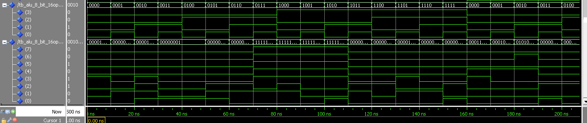

FIGURE: Testbench waveform

Implementation on Spartan 7 FPGA

Spartan 7 FPGA development board
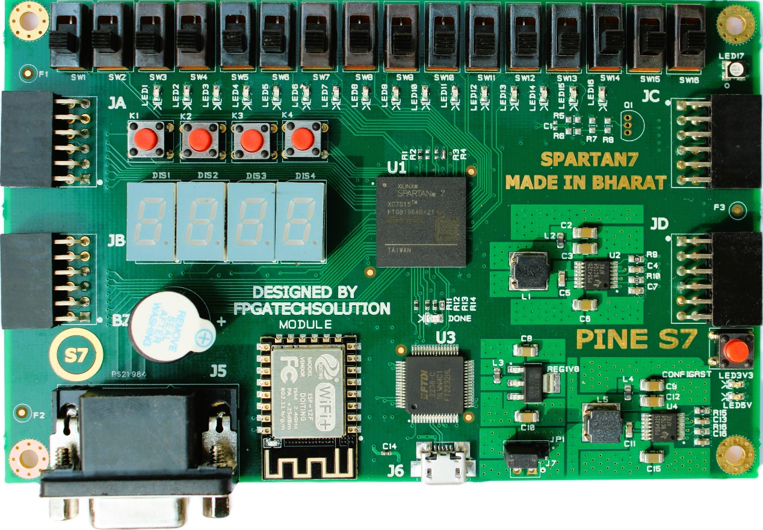
PINE S7 is an easy to use FPGA Development board featuring SPARTAN7 FPGA (XC7S15FTGB196-1), with FTDI’s FT2232H Dual-Channel USB device, which support Xilinx Vivado, SDK & Vitis to program FPGA. It is specially designed for the development and integration of FPGA based accelerated features to other designs. This board works with USB power however provision is given for external 5V power supply
Features
- 16 user switches
- 16 user LEDs
- 4 user pushbuttons
- 100MHz clock
- 4-digit 7-segment display
- Four Pmod ports
- ESP-12E WiFi
- Buzzer
- RGB LED
- VGA output
- USB-UART Bridge
- Serial Flash
- USB-JTAG port for FPGA programming and communication (support Vivado )

FPGA Configuration

The synthesized design is implemented on the FPGA using Vivado Design Suite. The seven-segment display is connected to the appropriate GPIO pins of the Spartan 7 FPGA development board. Pin assignments are made according to the board's pinout configuration.

Constraint File (.XDC file)

set_property -dict { PACKAGE_PIN A5 IOSTANDARD LVCMOS33 } [get_ports {A[0]}]
set_property -dict { PACKAGE_PIN B6 IOSTANDARD LVCMOS33 } [get_ports {A[1]}]
set_property -dict { PACKAGE_PIN F4 IOSTANDARD LVCMOS33 } [get_ports {A[2]}]
set_property -dict { PACKAGE_PIN C3 IOSTANDARD LVCMOS33 } [get_ports {A[3]}]
set_property -dict { PACKAGE_PIN C4 IOSTANDARD LVCMOS33 } [get_ports {A[4]}]
set_property -dict { PACKAGE_PIN A10 IOSTANDARD LVCMOS33 } [get_ports {A[5]}]
set_property -dict { PACKAGE_PIN B13 IOSTANDARD LVCMOS33 } [get_ports {A[6]}]
set_property -dict { PACKAGE_PIN C14 IOSTANDARD LVCMOS33 } [get_ports {A[7]}]

set_property -dict { PACKAGE_PIN D13 IOSTANDARD LVCMOS33 } [get_ports {B[0]}]
set_property -dict { PACKAGE_PIN F14 IOSTANDARD LVCMOS33 } [get_ports {B[1]}]
set_property -dict { PACKAGE_PIN G14 IOSTANDARD LVCMOS33 } [get_ports {B[2]}]
set_property -dict { PACKAGE_PIN H13 IOSTANDARD LVCMOS33 } [get_ports {B[3]}]
set_property -dict { PACKAGE_PIN D12 IOSTANDARD LVCMOS33 } [get_ports {B[4]}]
set_property -dict { PACKAGE_PIN E12 IOSTANDARD LVCMOS33 } [get_ports {B[5]}]
set_property -dict { PACKAGE_PIN F11 IOSTANDARD LVCMOS33 } [get_ports {B[6]}]
set_property -dict { PACKAGE_PIN H11 IOSTANDARD LVCMOS33 } [get_ports {B[7]}]

set_property -dict { PACKAGE_PIN B5 IOSTANDARD LVCMOS33 } [get_ports {SEL[0]}]
set_property -dict { PACKAGE_PIN A4 IOSTANDARD LVCMOS33 } [get_ports {SEL[1]}]
set_property -dict { PACKAGE_PIN A3 IOSTANDARD LVCMOS33 } [get_ports {SEL[2]}]
set_property -dict { PACKAGE_PIN B3 IOSTANDARD LVCMOS33 } [get_ports {SEL[3]}]

set_property -dict { PACKAGE_PIN F3 IOSTANDARD LVCMOS33 } [get_ports {Y[0]}]
set_property -dict { PACKAGE_PIN E4 IOSTANDARD LVCMOS33 } [get_ports {Y[1]}]
set_property -dict { PACKAGE_PIN D3 IOSTANDARD LVCMOS33 } [get_ports {Y[2]}]
set_property -dict { PACKAGE_PIN D4 IOSTANDARD LVCMOS33 } [get_ports {Y[3]}]
set_property -dict { PACKAGE_PIN C5 IOSTANDARD LVCMOS33 } [get_ports {Y[4]}]
set_property -dict { PACKAGE_PIN A12 IOSTANDARD LVCMOS33 } [get_ports {Y[5]}]
set_property -dict { PACKAGE_PIN A13 IOSTANDARD LVCMOS33 } [get_ports {Y[6]}]
set_property -dict { PACKAGE_PIN B14 IOSTANDARD LVCMOS33 } [get_ports {Y[7]}]

Testing and Results

The FPGA is configured with the synthesized design, and various BCH inputs are applied to verify the numerical representation on the seven-segment display. The testing process involves:

- Configuring the FPGA with the synthesized design.

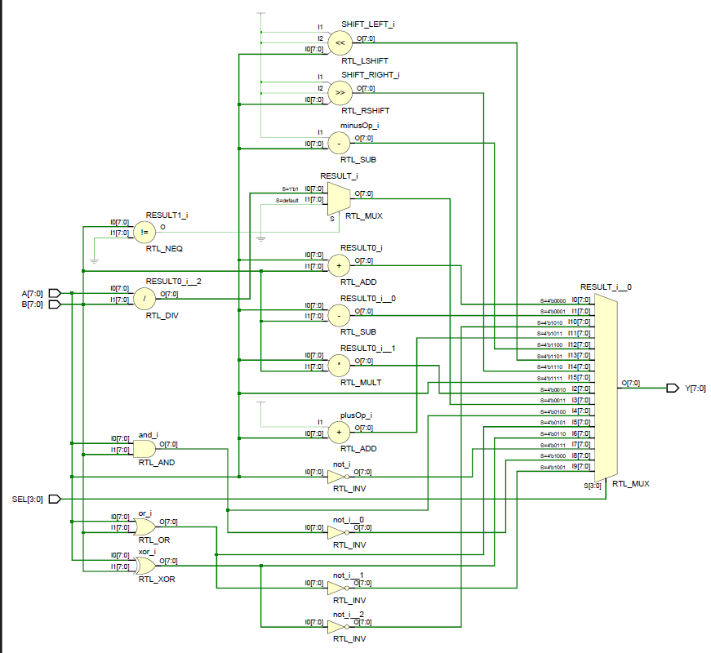
FIGURE: Synthesized Design

- Applying test inputs using switches or buttons on the FPGA board.

- Observing and verifying the outputs on the seven-segment display.

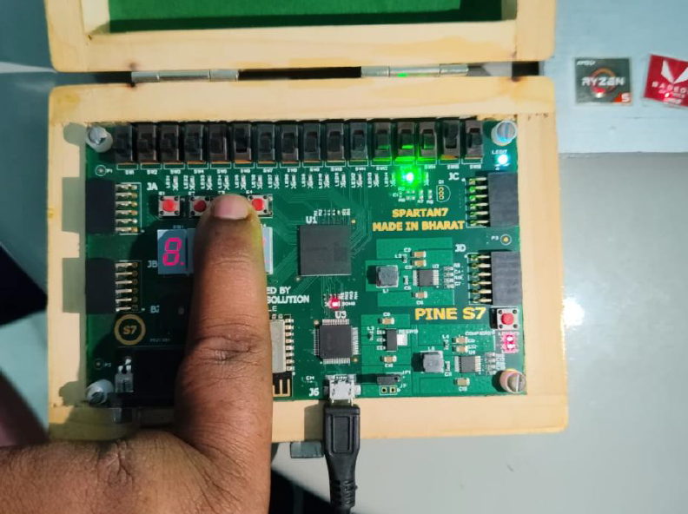

Figure: Output image of the FPGA Board

Conclusion

FPGAs are powerful tools in the field of digital design, offering unparalleled flexibility and performance for a wide range of applications. Their ability to be reprogrammed and customized makes them ideal for industries where rapid prototyping and iteration are crucial. As technology advances, FPGAs continue to play a vital role in the development of modern electronic systems.

In this project, an 8-bit ALU with 16 operations was successfully designed, simulated, and implemented on the FPGA. The design was verified using ModelSim and mapped to the PINE S7 board using appropriate constraints, demonstrating practical understanding of VHDL design, simulation, and hardware realization.

References
- Short, K. L. (2009). VHDL for Engineers. Prentice Hall.
- Chang, K. C. (1997). Digital Design and Modeling with VHDL and Synthesis. IEEE Computer Society Press.
- Perry, D. L. (2002). VHDL: Programming by Example. McGraw-Hill.
- Ashenden, P. J. (2008). The Designer’s Guide to VHDL. Morgan Kaufmann.
- VHDLwhiz. (n.d.). VHDL Reference Guide. Retrieved from https://vhdlwhiz.com
- Digi-Key Electronics. (n.d.). Introduction to VHDL. Retrieved from https://www.digikey.com/en/resources/design-tools/technical-reference/vhdl
- Kumar, R., & Das, S. (2015). VHDL in Digital System Design and Synthesis. International Journal of Electronics and Communication Engineering, 7(2), 145-152.
- Smith, J., Johnson, M., & Brown, A. (2018). A Review of VHDL-Based Digital Design Techniques. IEEE Transactions on Education, 61(3), 234-245.
- Xilinx Inc. (2023). Vivado Design Suite User Guide. Retrieved from https://www.xilinx.com/support/documentation-navigation/design-hubs.html.
- Xilinx Inc. (2023). Spartan-7 FPGA Family Data Sheet. Retrieved from https://www.xilinx.com/products/silicon-devices/fpga/spartan-7.html.

